Practical 12.

Q1) Modify the given program to use criterion= "entropy" instead of "Gini".
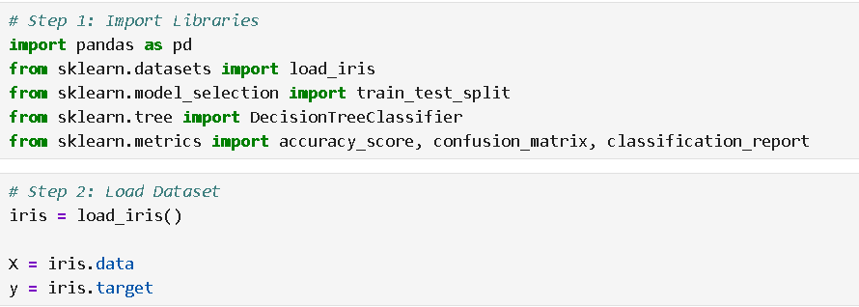

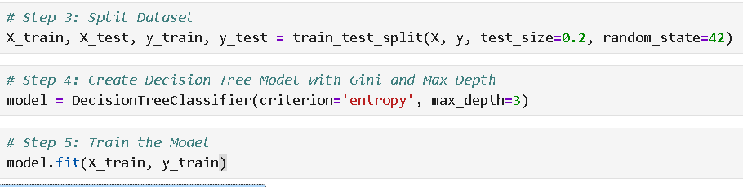

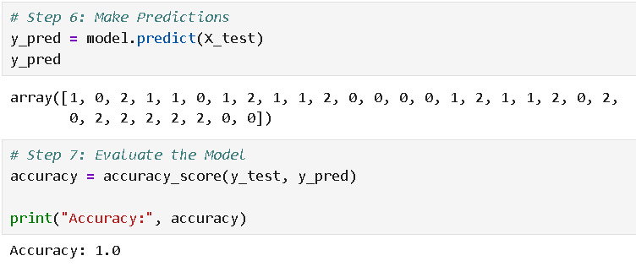
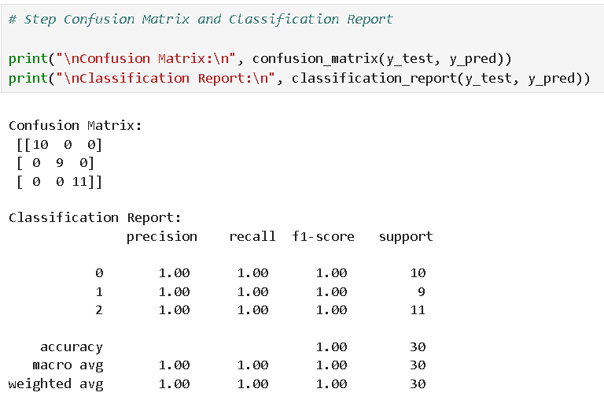

Q2. Build a simple decision-support system for medical diagnosis using a decision tree.
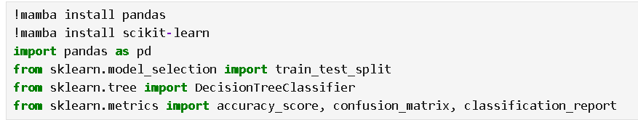
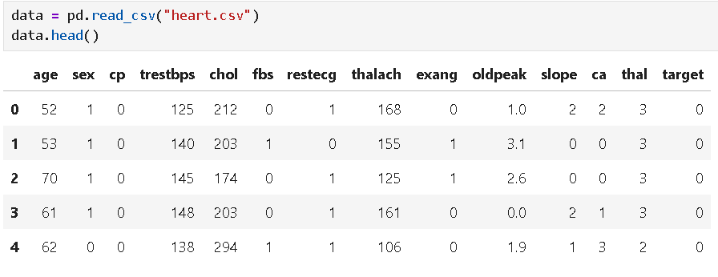
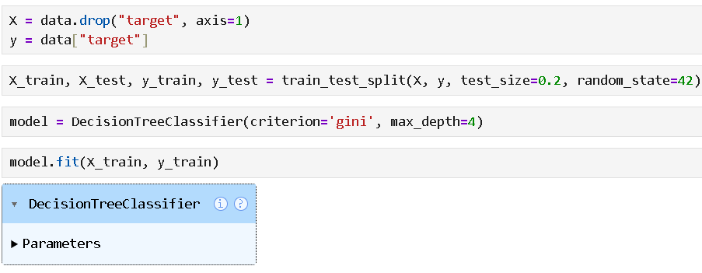
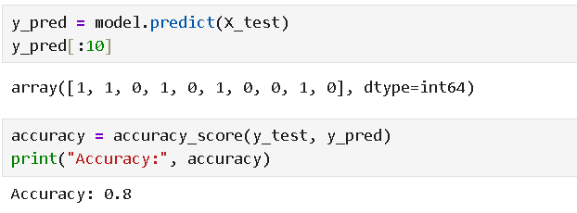
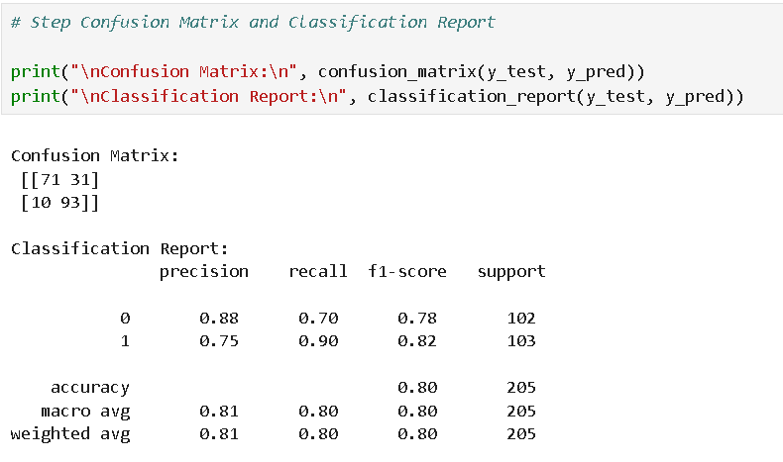

[[TN FP] 71 31
[FN TP]] 10 93

Term |  | Meaning | Value
TN | Actual 0 and Predicted 0 |  | 71
FP | Actual 0 and Predicted 1 |  | 31
FN | Actual 1 and Predicted 0 |  | 10
TP | Actual 1 and Predicted 1 |  | 93

Entropy and Gini are measures used in Decision Trees to check how pure or mixed the data is.
Pure data → all items belong to one class
Impure data → mixture of different classes

Entropy
Measures uncertainty in the data.
Uncertainty in data means we are not sure which class a data point belongs to.

CASE 2
Apple Apple Apple Apple
If you pick one fruit, you are 100% sure it will be an Apple.
So:
Uncertainty = 0

CASE 2
Apple Apple Orange Orange
If you pick a fruit, you don't know whether it will be Apple or Orange.
So:
Uncertainty = High

Gini measures the probability of wrong classification
It tells us how likely it is that a data point will be classified incorrectly.
8 Apples
2 Oranges
If we randomly pick a fruit and try to guess its class, there is a small chance we may guess wrong.
That chance of being wrong is what Gini measures.

